17. HANDLING MISSING VALUES
Aim
To load a dataset containing missing values and handle the missing values by replacing numerical missing values with the mean/median and categorical missing values with the mode.
Algorithm
1. Start.
2. Import the required Python libraries such as Pandas and NumPy.
3. Create or load a dataset containing missing values.
4. Identify the missing values using isnull().sum().
5. Separate the numerical and categorical columns.
6. Replace missing values in numerical columns with the mean (or median).
7. Replace missing values in categorical columns with the mode.
8. Verify that no missing values remain.
9. Display the cleaned dataset.
10. Stop.

Code
import pandas as pd
import numpy as np
# Create a dataset containing missing values
data = {
'Name': ['Arun', 'Priya', 'Rahul', 'Sneha', 'Karthik'],
'Age': [20, 21, np.nan, 22, np.nan],
'Marks': [85, np.nan, 78, 92, np.nan],
'Department': ['CSE', 'AI&DS', np.nan, 'CSE', 'AI&DS'],
'City': ['Chennai', 'Vellore', 'Chennai', np.nan, 'Chennai']
}
df = pd.DataFrame(data)
# Check missing values before handling
print("Missing Values Before Handling:")
print(df.isnull().sum())
# Replace numerical missing values with the mean
numerical_columns = df.select_dtypes(include=np.number).columns
for column in numerical_columns:
df[column] = df[column].fillna(df[column].mean())
# Replace categorical missing values with the mode
categorical_columns = df.select_dtypes(include='object').columns
for column in categorical_columns:
df[column] = df[column].fillna(df[column].mode()[0])
# Display cleaned dataset
print("\nDataset After Handling Missing Values:")
display(df)
# Verify missing values
print("Missing Values After Handling:")
print(df.isnull().sum())

Output Screenshot
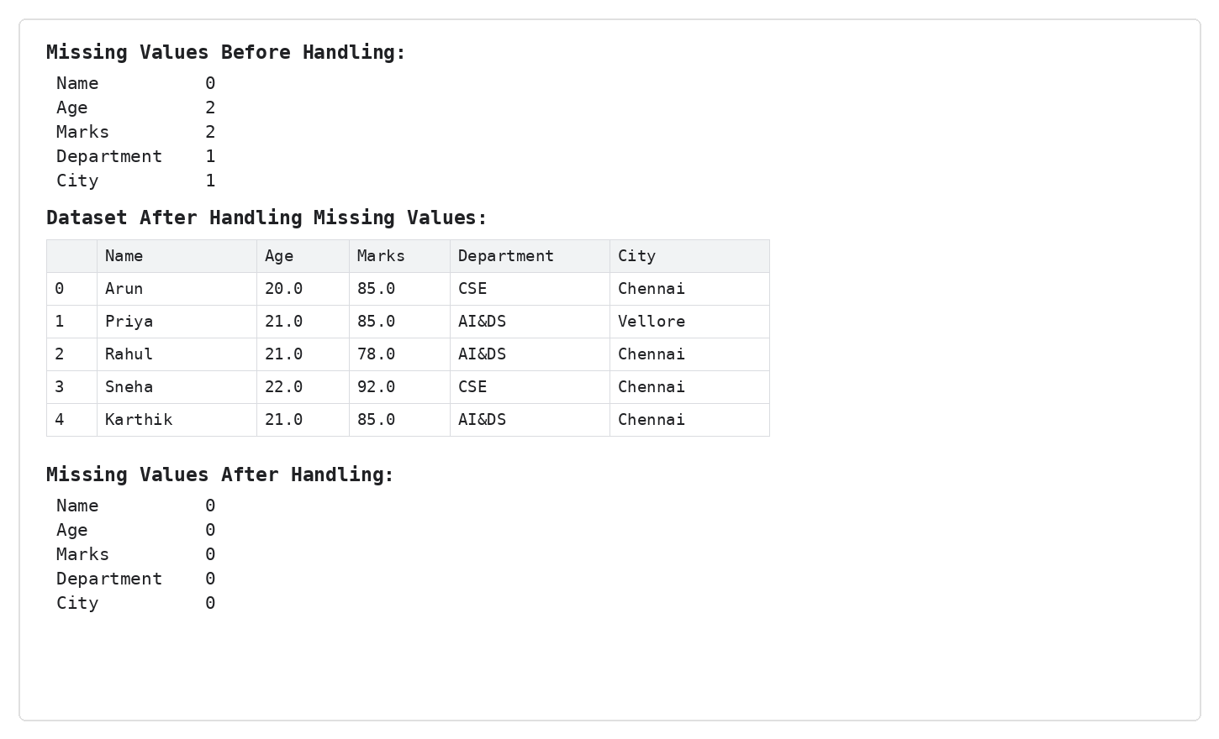
Result
Thus, the missing values were successfully handled. Numerical missing values were replaced with the mean and categorical missing values were replaced with the mode. The final verification shows zero missing values in all columns.

